|  |  |
| --- | --- |
| *Pacific Gas and Electric Company* | |
| Release 8.5.1 Installation Guide | |
|  |  |
|  |  |
| Project | ED AM/GIS |
|  |  |
| Prepared by | Ashish Narasimham |
| Date | 7/29/2014 |
| Version | 1.0 |
| Version Type | Final |

|  |  |  |  |
| --- | --- | --- | --- |
| Revision History | | | |
| Document # | Date | Author | Summary of Changes |
| 1.0 | 7/28/14 | Ashish Narasimham | Initial Document Creation |

# Introduction

## Purpose

This document is intended to detail the implementation and configuration steps required to implement Release 8.5.1 Installation Guide. This document describes the various configuration aspects required to complete any manual or automatic patch associated with this release. Each section in this document contains the steps required to patch the system in production.

## Terms Used

|  |  |
| --- | --- |
| OOTB | Out of the box. Unmodified from the commercial version. |
| TFS | Team Foundation Server |

## External Documents

Referenced are any external configuration documents or exports. These are documents that contain more detailed information about configuring a system or documents that can be loaded into an application to perform the configuration detailed in this document.

## List Of Fixes

Below is the list of change requests detailing all fixes for the data model for this release:

|  |  |  |  |
| --- | --- | --- | --- |
| **Item Number** | | **Title** | **Work Item Type** |
| [16555](http://edappgistfsprd1:8080/tfs/web/wi.aspx?pcguid=15e9a9d1-95cb-4dd0-abfe-5af14ae6201f&id=16555) | | Master for Release 8.5.1, for Data Conversion | Change Request |
| [16536](http://edappgistfsprd1:8080/tfs/web/wi.aspx?pcguid=15e9a9d1-95cb-4dd0-abfe-5af14ae6201f&id=16536) | DA Issue: Add Leader Line Feature to the ED GIS Data Model | Change Request |
| [16491](http://edappgistfsprd1:8080/tfs/web/wi.aspx?pcguid=15e9a9d1-95cb-4dd0-abfe-5af14ae6201f&id=16491) | PAR 64063: Transformer Overstriking in SFO | Change Request |

## Summary of Steps to Complete Install

Contents

1 Introduction 3

1.1 Purpose 3

1.2 Terms Used 3

1.3 External Documents 3

1.4 List Of Fixes 4

1.5 Summary of Steps to Complete Install 5

2 Open a Database Connection in ArcCatalog 6

3 Data Model CR to add New Line Feature Class "LeaderLine" 7

4 PAR 64063: Transformer Overstriking in SFO 11

5 Update Data Model Version Table 13

6 Known Issues 14

# Open a Database Connection in ArcCatalog

1. Open ArcCatalog.
2. Within the Catalog Tree, expand “Database Connections” and open the active connection for this process. This is the connection that is referenced in the change request associated with this document (EDGIS<DB name in the format X#Y> )

# Data Model CR to add New Line Feature Class "LeaderLine"

1. Right click on the Electric Dataset and select New->Feature Class.
   1. Name: LeaderLine
   2. Alias: Leader Line
   3. ArcFM Feature, Line Feature  
      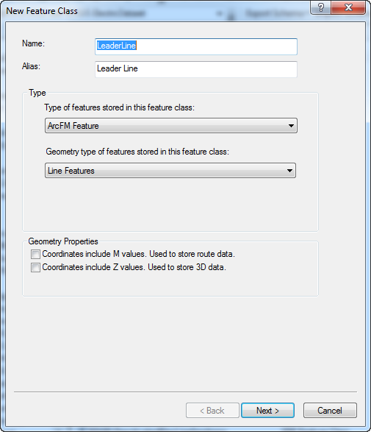
   4. Keep the next screen as is  
      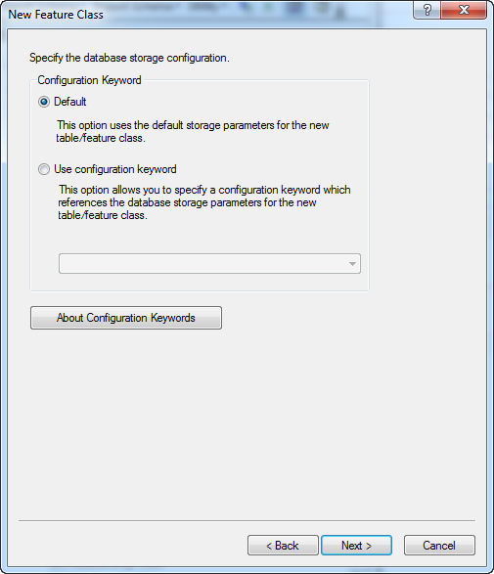
   5. Add the following fields
      1. Field: SUBTYPECD  
         Type: Long Integer  
         Alias: Subtype  
         Allow NULLS: No  
         Default value: 1

Precision: 10

* + 1. Field: CREATIONUSER  
       Type: Text  
       Alias: Creation User  
       Allow NULLS: Yes  
       Length: 15
    2. Field: DATECREATED  
       Type: Date  
       Alias: Date Created  
       Allow NULLS: Yes
    3. Field: DATEMODIFIED  
       Type: Date  
       Alias: Date Modified  
       Allow NULLS: Yes
    4. Field: LASTUSER  
       Type: Text  
       Alias: Last User  
       Allow NULLS: Yes  
       Length: 15

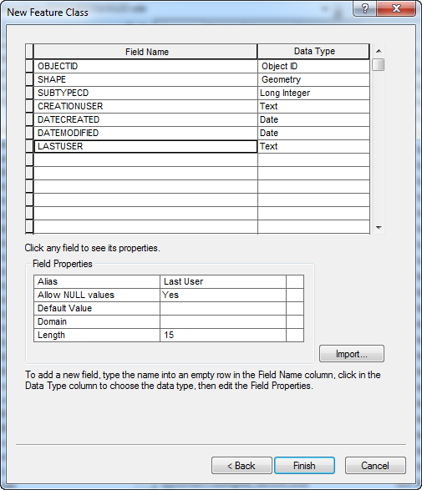

* 1. Click Finish.
  2. Double click the newly created feature class and select the Subtypes tab.
  3. Select SUBTYPECD for the Subtype field dropdown and populate the subtypes as follows:  
     0 – Primary UG Conductor  
     1 – Secondary UG Conductor  
     2 – DC Conductor  
     3 – Other

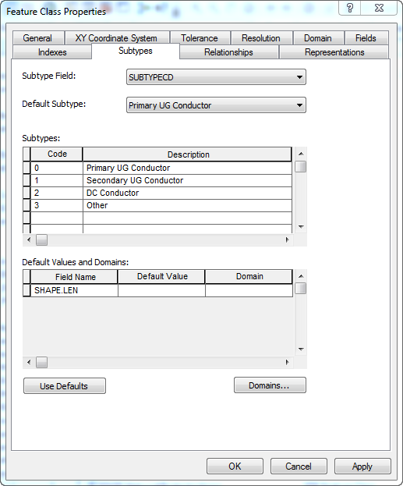

* 1. Click OK.

# PAR 64063: Transformer Overstriking in SFO

1. Right click the database connection and select Properties.
2. Select the Domains tab and scroll down to the bottom of the list.
3. Create a new domain, SymbolSpace:  
   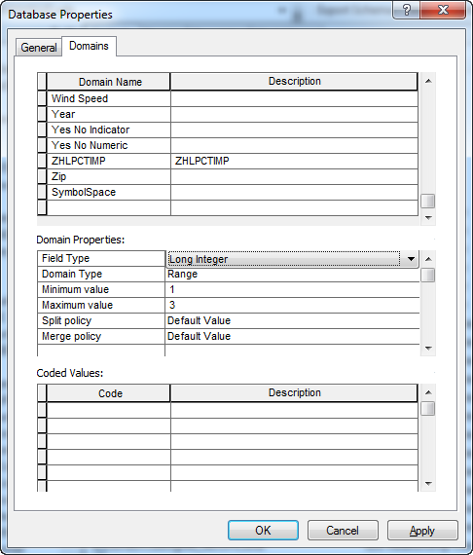
4. Select OK.
5. In the ElectricDataset, browse to the Transformer feature class and double click it.
6. In the Fields tab, scroll to the bottom of the list and create a new field, SymbolSpace:

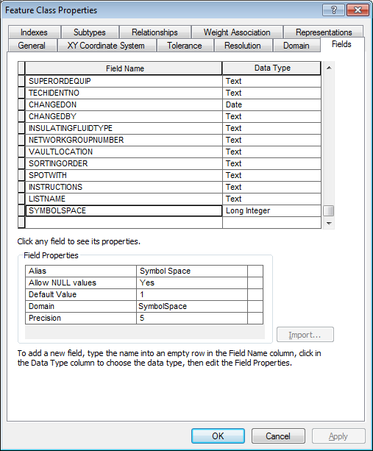

1. Select Apply and go to the Subtypes tab.
2. Select the subtype row from the list of subtypes in the upper box.
3. Scroll to the SYMBOLSPACE field and set the following domains for the following subtypes:

Distribution Overhead - SymbolSpace

Distribution Subsurface – N/A

Distribution Padmount – N/A

Equipment – SymbolSpace

Network – SymbolSpace

Street Light – SymbolSpace

Secondary – N/A

1. Select OK.

# Update Data Model Version Table

**Database Configuration:**

1. Open SQL Plus.
2. Log in using the same server and user as was used in section 2.  
     
   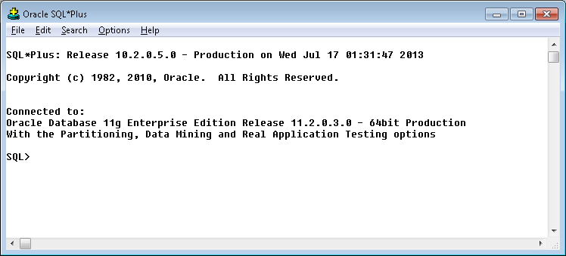
3. Run the SQL below:

update pgedatamodelversion set currentidc='N' where currentidc='Y';

insert into pgedatamodelversion (OBJECTID, CURRENTIDC, DATEAPPLIED, APPLIEDBYPERSONNAME, MODELVERSION) values (**65**,'Y',sysdate,'**<INSERT TEAM MEMBER DONE BY>**','**8.5.1** GOLD **CR16555**');

commit;

# Known Issues

<Please List any other issues encountered here while following the document>